Name:_______________________________

**Binary Numeral System**

The electrical circuits on an IC have one of two states, off or on. Therefore, the binary number system (base 2), which uses only two digits (0 and 1), was adopted for use in computers. To represent numbers and letters, a code was developed with eight binary digits grouped together to represent a single number or letter. Each 0 or 1 in the binary code is called a bit (Binary digit) and an 8-bit unit is called a byte.

**Binary System** – A numbering system that represents numbers and data in which only the digits 1 and 0 are used. Successive units are based on the power of 2.

**A Visual Representation**

|  |  |  |  |  |  |  |  |
| --- | --- | --- | --- | --- | --- | --- | --- |
| **128s** | **64s** | **32s** | **16s** | **8s** | **4s** | **2s** | **1s** |
|  |  |  |  |  |  |  |  |
|  |  |  |  |  |  |  |  |
|  |  |  |  |  |  |  |  |
|  |  |  |  |  |  |  |  |
|  |  |  |  |  |  |  |  |

|  |  |  |
| --- | --- | --- |
| **Row** | **Light Bulbs On** | **Number Represented** |
| 1 | None | 0 |
| 2 | 1s Column | 1 |
| 3 | 2s & 1s Column (2 + 1) | 3 |
| 4 | 64s & 2s Column ( 64 + 2) | 66 |
| 5 | 16s & 4s Column (16 + 4) | 20 |

**But What About The 0s and 1s?**

**Let’s say that a light bulb that is off equals 0 and a light bulb that is on equals 1…**

|  |  |  |  |  |  |  |  |
| --- | --- | --- | --- | --- | --- | --- | --- |
| **128s** | **64s** | **32s** | **16s** | **8s** | **4s** | **2s** | **1s** |
|  |  |  |  |  |  |  |  |
| **0** | **0** | **0** | **0** | **0** | **0** | **0** | **0** |
|  |  |  |  |  |  |  |  |
|  |  |  |  |  |  |  |  |
| **0** | **0** | **0** | **0** | **0** | **0** | **0** | **1** |
|  |  |  |  |  |  |  |  |
|  |  |  |  |  |  |  |  |
| **0** | **0** | **0** | **0** | **0** | **0** | **1** | **1** |
|  |  |  |  |  |  |  |  |
|  |  |  |  |  |  |  |  |
| **0** | **1** | **0** | **0** | **0** | **0** | **1** | **0** |
|  |  |  |  |  |  |  |  |
|  |  |  |  |  |  |  |  |
| **0** | **0** | **0** | **1** | **0** | **1** | **0** | **0** |

**Remember…..**

|  |  |
| --- | --- |
| **Row** | **Number Represented** |
| 1 | 0 |
| 2 | 1 |
| 3 | 3 |
| 4 | 66 |
| 5 | 20 |

**Name:_______________________________**

**Now let’s try with no light bulbs….**

|  |  |  |  |  |  |  |  |  |
| --- | --- | --- | --- | --- | --- | --- | --- | --- |
| **128s** | **64s** | **32s** | **16s** | **8s** | **4s** | **2s** | **1s** | **Number Represented** |
| 0 | 0 | 0 | 0 | 1 | 0 | 1 | 0 | 10 |
| 0 | 1 | 0 | 1 | 0 | 1 | 0 | 1 | 85 |
| 1 | 1 | 1 | 0 | 0 | 0 | 0 | 0 | 224 |
| 0 | 0 | 0 | 0 | 0 | 1 | 1 | 1 | 7 |
| 1 | 1 | 1 | 1 | 1 | 0 | 0 | 0 | 248 |

**Now…I will give you the number you represent it in binary….**

|  |  |  |  |  |  |  |  |  |
| --- | --- | --- | --- | --- | --- | --- | --- | --- |
| **128s** | **64s** | **32s** | **16s** | **8s** | **4s** | **2s** | **1s** | **Number Represented** |
| 0 | 0 | 0 | 0 | 0 | 1 | 0 | 0 | 4 |
| 0 | 0 | 0 | 0 | 0 | 1 | 0 | 1 | 5 |
| 0 | 0 | 0 | 1 | 1 | 0 | 1 | 1 | 27 |
| 0 | 0 | 1 | 0 | 0 | 1 | 0 | 0 | 36 |
| 0 | 0 | 1 | 1 | 0 | 0 | 1 | 1 | 51 |

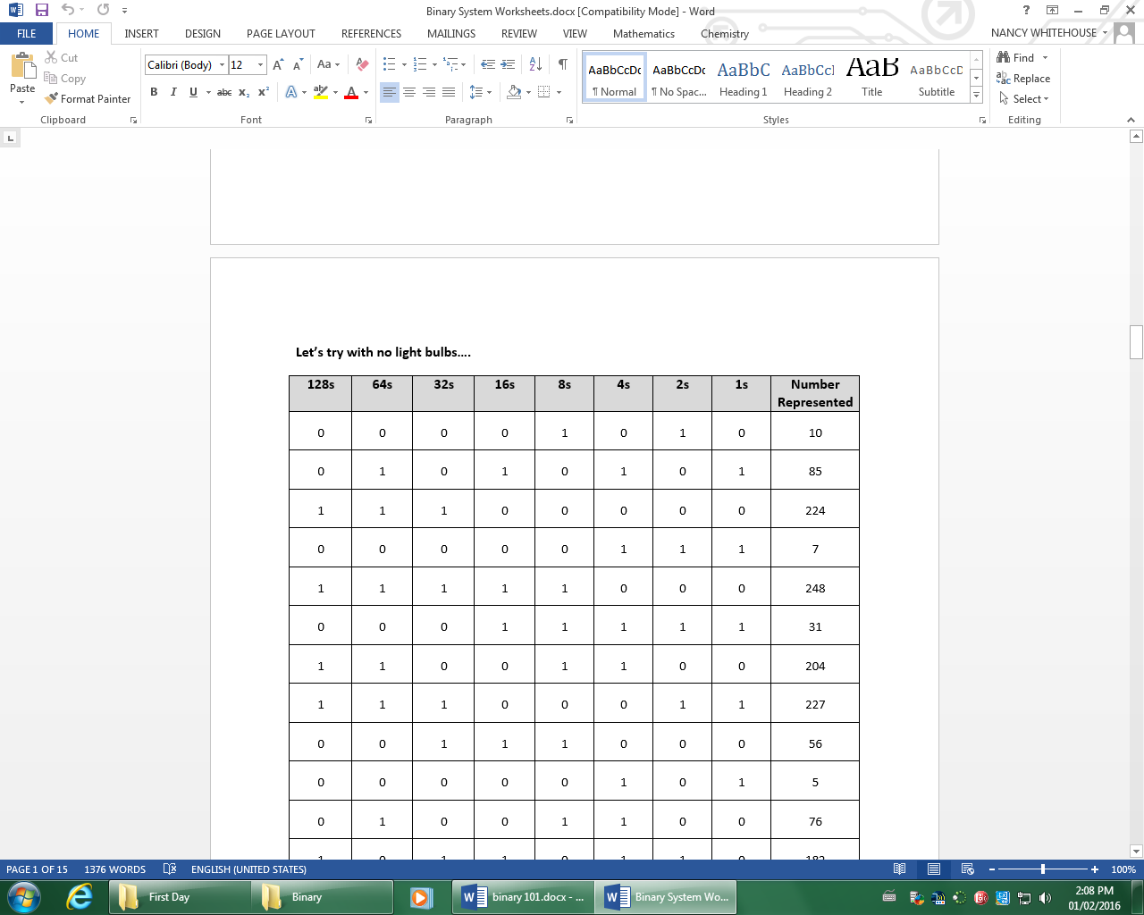

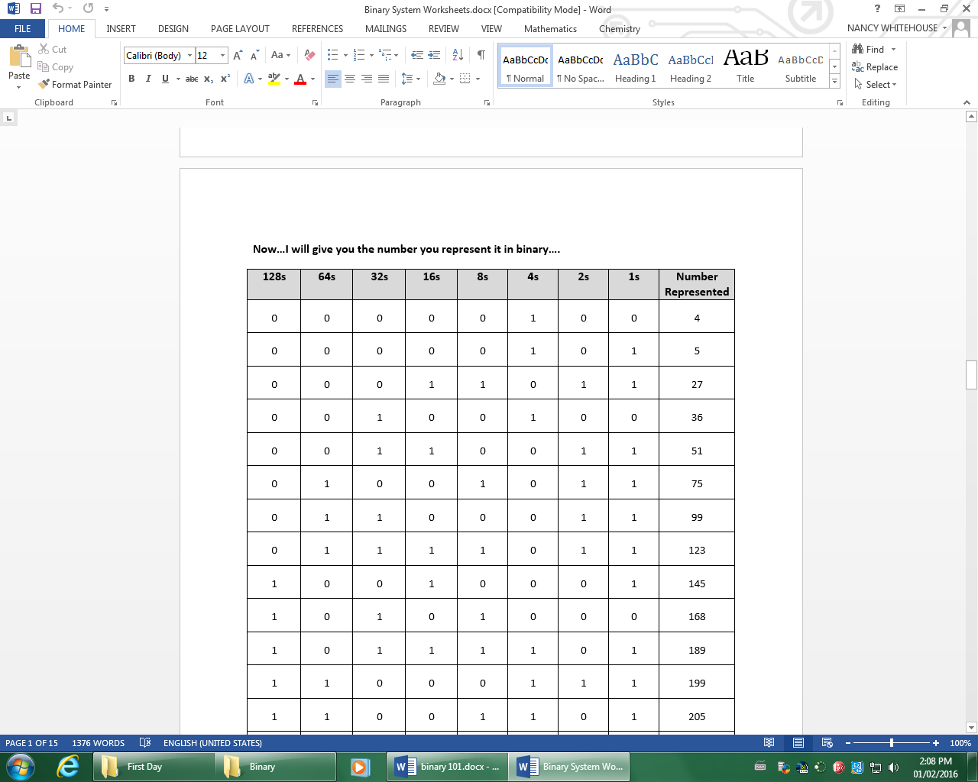

**Now what about letters? How are they represented in binary?**

**ASCII –** American Standard Code for Information Interchange is a standard for assigning numerical values to letters.

ASCII Table – [www.asciitable.com](http://www.asciitable.com)

|  |  |  |  |  |
| --- | --- | --- | --- | --- |
| **Decimal Number** | **Letter Represented** |  | **Decimal Number** | **Letter Represented** |
| **65** | **A** |  | **97** | **a** |
| **66** | **B** |  | **98** | **b** |
| **67** | **C** |  | **99** | **c** |
| **68** | **D** |  | **100** | **d** |
| **69** | **E** |  | **101** | **e** |
| **70** | **F** |  | **102** | **f** |
| **71** | **G** |  | **103** | **g** |
| **72** | **H** |  | **104** | **h** |
| **73** | **I** |  | **105** | **i** |
| **74** | **J** |  | **106** | **j** |
| **75** | **K** |  | **107** | **k** |
| **76** | **L** |  | **108** | **l** |
| **77** | **M** |  | **109** | **m** |
| **78** | **N** |  | **110** | **n** |
| **79** | **O** |  | **111** | **o** |
| **80** | **P** |  | **112** | **p** |
| **81** | **Q** |  | **113** | **q** |
| **82** | **R** |  | **114** | **r** |
| **83** | **S** |  | **115** | **s** |
| **84** | **T** |  | **116** | **t** |
| **85** | **U** |  | **117** | **u** |
| **86** | **V** |  | **118** | **v** |
| **87** | **W** |  | **119** | **w** |
| **88** | **X** |  | **120** | **x** |
| **89** | **Y** |  | **121** | **y** |
| **90** | **Z** |  | **122** | **z** |

**So let’s say we wanted to translate “HELLO” into binary. We would need to use the ASCII Table to find the decimal number that corresponds with the letter. Then we could translate the decimal number into binary.**

|  |  |  |  |  |  |  |  |  |  |
| --- | --- | --- | --- | --- | --- | --- | --- | --- | --- |
| **Letter** | **Decimal Number** | **128s** | **64s** | **32s** | **16s** | **8s** | **4s** | **2s** | **1s** |
| **H** | 72 | 0 | 1 | 0 | 0 | 1 | 0 | 0 | 0 |
| **E** | 69 | 0 | 1 | 0 | 0 | 0 | 1 | 0 | 1 |
| **L** | 76 | 0 | 1 | 0 | 0 | 1 | 1 | 0 | 0 |
| **L** | 76 | 0 | 1 | 0 | 0 | 1 | 1 | 0 | 0 |
| **O** | 79 | 0 | 1 | 0 | 0 | 1 | 1 | 1 | 1 |

**Translate your first name into binary**

|  |  |  |  |  |  |  |  |  |  |
| --- | --- | --- | --- | --- | --- | --- | --- | --- | --- |
| **Letter** | **Decimal Number** | **128s** | **64s** | **32s** | **16s** | **8s** | **4s** | **2s** | **1s** |
| **T** | 84 | 0 | 1 | 0 | 1 | 0 | 1 | 0 | 0 |
| **A** | 65 | 0 | 1 | 0 | 0 | 0 | 0 | 0 | 1 |
| **H** | 72 | 0 | 1 | 0 | 0 | 1 | 0 | 0 | 0 |
| **M** | 77 | 0 | 1 | 0 | 0 | 1 | 1 | 0 | 1 |
| **I** | 73 | 0 | 1 | 0 | 0 | 1 | 0 | 0 | 1 |
| **D** | 68 | 0 | 1 | 0 | 0 | 0 | 1 | 0 | 0 |
|  |  |  |  |  |  |  |  |  |  |
|  |  |  |  |  |  |  |  |  |  |
|  |  |  |  |  |  |  |  |  |  |
|  |  |  |  |  |  |  |  |  |  |
|  |  |  |  |  |  |  |  |  |  |
|  |  |  |  |  |  |  |  |  |  |
|  |  |  |  |  |  |  |  |  |  |

**Definitions**

|  |  |
| --- | --- |
| |  | | --- | | * + 1. **Bit -** A unit of information expressed as either a 0 or 1 in binary notation | |

**Byte -** a byte is a unit of data that is eight binary digits long or eight bits

**Kilobyte –** 1000 bytes

**Megabyte –** 1,000,000 bytes (million)

**Gigabyte –** 1,000,000,000 bytes (billion)

**Terabyte –** trillion bytes

